Market Monitor - Democratic Republic of the Congo - 2026-05

Highlights
In May 2026, the cost of the food basket in DRC saw a notable decrease, driven by falling prices for most staple foods. However, a massive spike in the price of raw maize and a surge in palm oil prices signal potential future inflation.
The cost of the food basket decreased by 8.8% (↓) month-on-month and 17.1% (↓) year-on-year.
The market was defined by contradictory movements, with a hyperinflationary monthly spike in Maize (↑69.0%) and a surge in Palm oil (↑21.1%), while Beans saw a sharp price drop (↓16.5%).
Key Drivers:
- The overall food basket decline was driven by broad-based price decreases, particularly for Beans (↓16.5%) and Wheat flour (↓18.7%).
- Strong inflationary pressure came from a massive month-on-month price surge for raw Maize (↑69.0%) and Palm oil (↑21.1%), running counter to the general trend.
- The Congolese Franc (CDF) remained stable and continued its appreciating trend, gaining 0.9% against the USD in May, which helped to lower the cost of imported goods like Rice (↓7.3%).
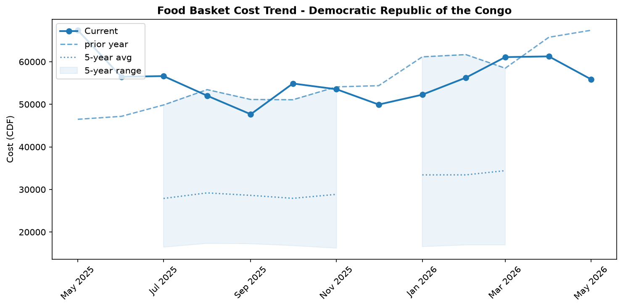
Food basket cost trend

Market Overview
In May 2026, the Democratic Republic of the Congo's markets presented a complex and contradictory picture. On the surface, conditions appeared to improve for consumers as the cost of the national food basket registered a significant month-on-month decrease of 8.8 percent, driven by broad-based price drops in most staple foods. This deflationary trend, however, is set against a backdrop of escalating inflationary pressures that threaten its sustainability. Sharply rising fuel prices, with diesel and petrol increasing by 8.7 and 9.6 percent respectively, are driving up transportation and production costs. Furthermore, the long-term weakness of the Congolese Franc, which has depreciated over 20 percent year-on-year, continues to inflate the cost of imported goods. The market environment is further destabilized by significant non-economic shocks. The declaration of a Public Health Emergency of International Concern for Bundibugyo virus disease, coupled with an ongoing Ebola outbreak and acute insecurity in the eastern provinces, is severely disrupting supply chains and humanitarian access. These underlying pressures suggest the current relief in food prices is fragile and likely to be short-lived, with a return to inflation expected in the near term.

Commodity Analysis
The 8.8 percent monthly decline in the food basket was primarily fueled by a sharp 16.5 percent drop in the price of beans, which are now 21.6 percent cheaper than last year. This masked significant volatility among other key commodities. A major market anomaly emerged between maize and its processed form; while maize flour prices decreased modestly by 3.1 percent, the price of raw maize grain surged by an alarming 69.0 percent in a single month. This stark divergence signals a critical lag in price transmission, with the spike in raw material costs poised to trigger a sharp reversal and increase in maize flour prices in the coming weeks. Palm oil was the only food basket component to register an increase, jumping 21.1 percent month-on-month, though it remains 4.5 percent below its price a year ago. Counteracting the food price deflation, the energy sector exerted strong inflationary pressure. National average prices for diesel and petrol climbed by 8.7 percent and 9.6 percent, respectively. Year-on-year, fuel prices are up over 10 percent, consistently increasing production and transport overheads and threatening to push the cost of all commodities higher.
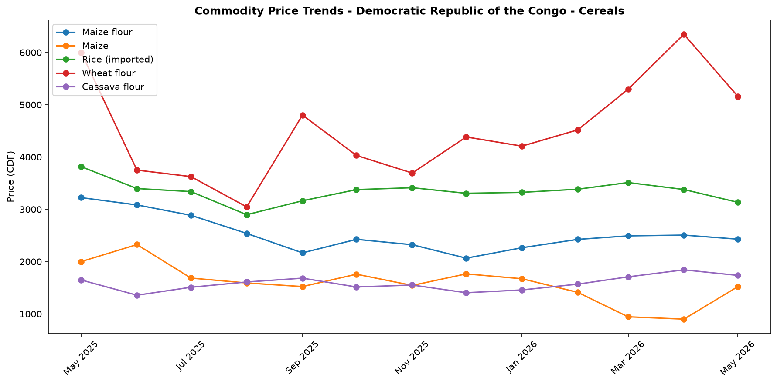
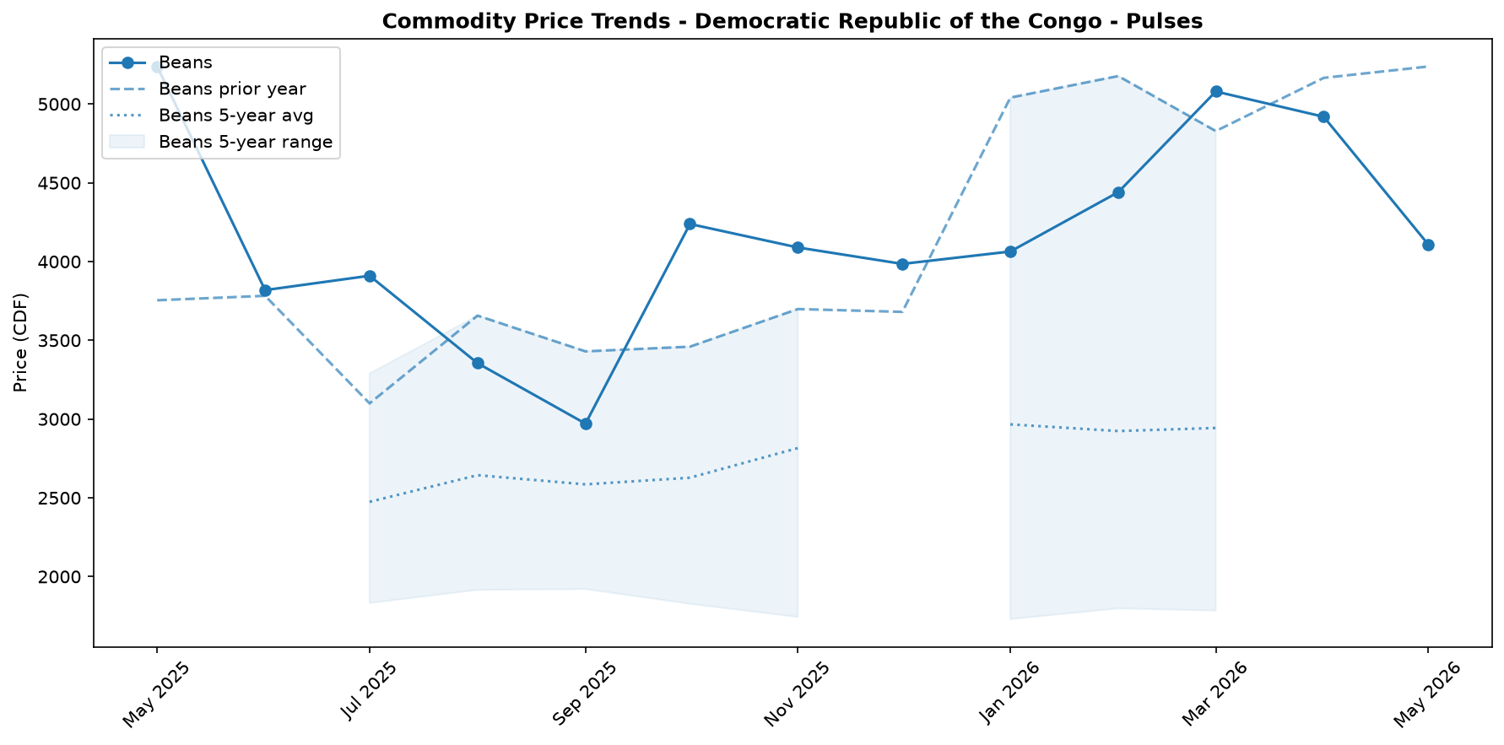
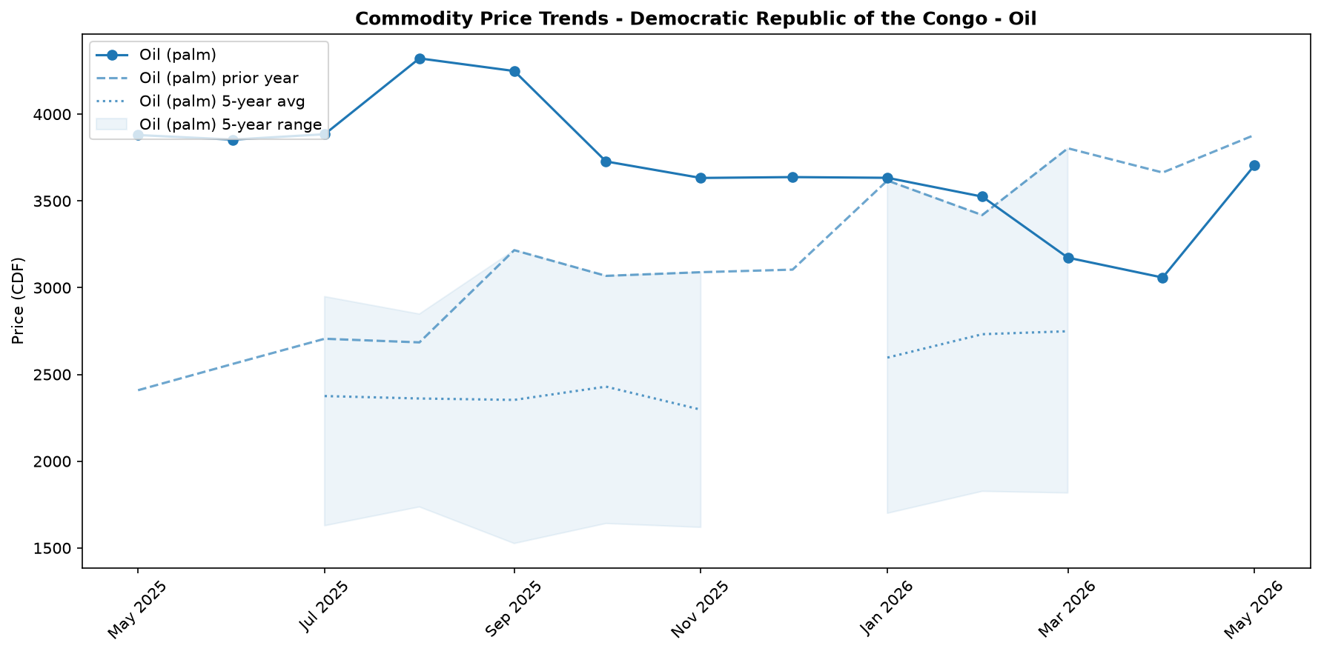
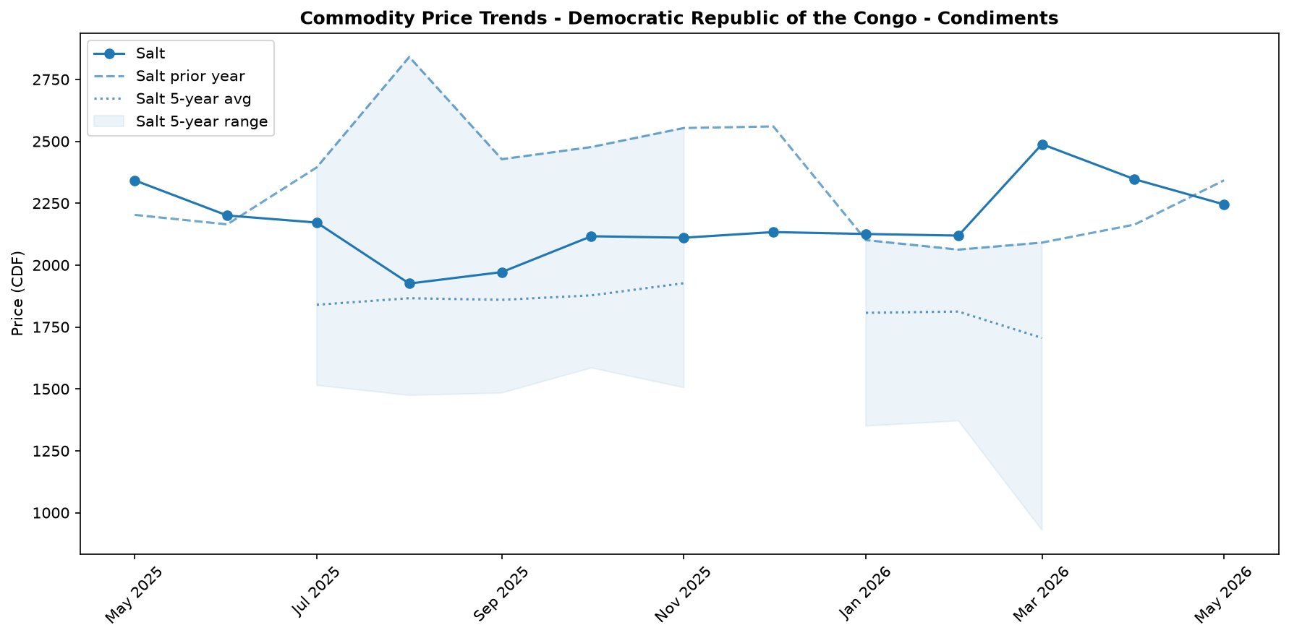

Regional Highlights
Extreme regional price disparities, particularly in the fuel market, highlight severe logistical bottlenecks and the impact of insecurity on supply chains. The data reveals a fractured market where the price of diesel in the Bas-Uele region is a staggering 249.3 percent higher than in Kongo-Central.
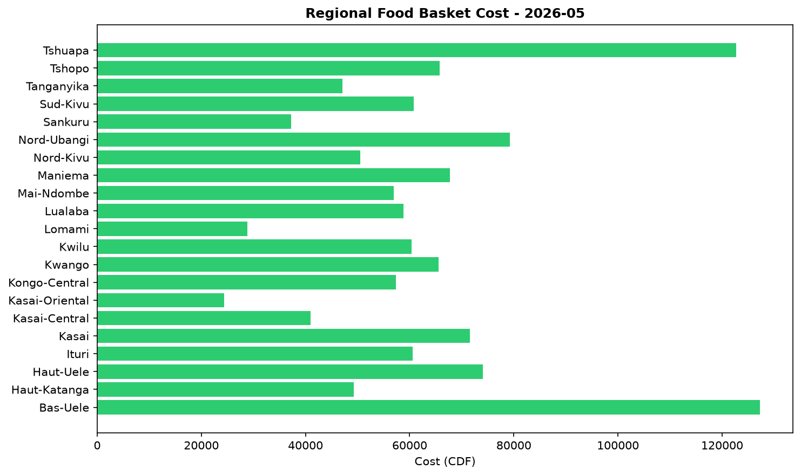
This vast price gap underscores the immense challenges in transporting essential goods across the country. The situation is exacerbated by the security and health crises concentrated in the eastern DRC. Acute insecurity and armed conflict in Ituri, North Kivu, and South Kivu—the same provinces battling outbreaks of Ebola and Bundibugyo virus disease—severely restrict the movement of goods and humanitarian aid. These disruptions lead to localized shortages and price shocks, disproportionately affecting populations already facing displacement and health emergencies. Such fragmentation not only creates severe hardship in isolated regions but also undermines the stability and efficiency of the national market as a whole.

Fuel & Energy
In May, the national average price of diesel increased by 8.7 percent to CDF 4,728.7 per litre, up 11.0 percent year-on-year, while petrol prices rose by 9.6 percent to CDF 4,723.85 per litre. This upward trend is consistent with significant supply and logistics constraints, which also contribute to extreme regional price disparities. These higher fuel costs exert inflationary pressure on food transport, threatening to increase staple food prices and erode household purchasing power, especially with diesel in Bas-Uele costing nearly 250 percent more than in Kongo-Central.
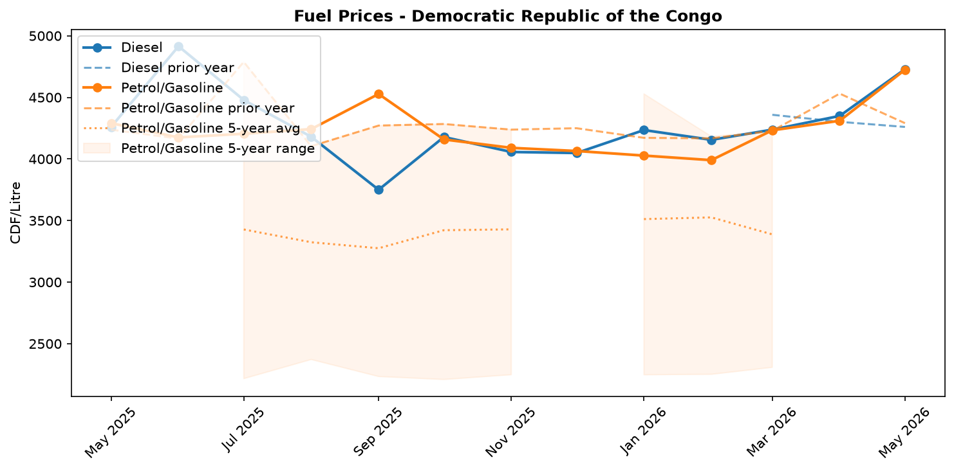
Fuel retail price trend

Exchange Rate Analysis
The Congolese Franc (CDF) has recently shown signs of appreciation, trading at an average of 2307.0 per USD. This represents a slight month-on-month strengthening of 0.94 percent, which could marginally ease the cost of imported goods in the short term. However, this recent gain contrasts sharply with the longer-term trajectory. Compared to the same period last year, the CDF has depreciated by a significant 20.57 percent. This substantial annual depreciation continues to exert strong upward pressure on the domestic prices of key imported commodities, including wheat, rice, cooking oil, and fuel. The persistent weakness of the currency over the year remains a primary driver of food price inflation and a key concern for household purchasing power, despite the minor recent gains.

References
- [rw_4214178] ReliefWeb (2026-05-31) IOM: Multi-Country Ebola Bundibugyo Outbreak Situation Report No. 2 (22 - 27 May 2026)
https://reliefweb.int/node/4214178
- [rw_4214159] ReliefWeb (2026-05-30) The metric of life and death: How local and technical experts are strengthening mortality measurement in Eastern DRC
https://reliefweb.int/node/4214159
- [rw_4214140] ReliefWeb (2026-05-29) Disease Outbreak News: Ebola disease caused by Bundibugyo virus - Democratic Republic of the Congo & Uganda (29 May 2026)
https://reliefweb.int/node/4214140
- [rw_4214053] ReliefWeb (2026-05-29) Democratic Republic of the Congo - Ituri Province: Solutions and Mobility Index | Cross-Border Stability Assessment (April 2026)
https://reliefweb.int/node/4214053
- [rw_4214043] ReliefWeb (2026-05-29) UNFPA Flash Update - Bundibugyo Ebola Virus Disease (BVD) Outbreak (20 - 26 May 2026)
https://reliefweb.int/node/4214043
- [rw_4214032] ReliefWeb (2026-05-29) Response to Ebola Outbreak in Democratic Republic of Congo (DRC) and Uganda
https://reliefweb.int/node/4214032
- [rw_4214019] ReliefWeb (2026-05-28) DRC Logistics and Telecommunications Cluster - Standard Operating Procedures (SOPs) for Common Logistics Services, May 2026
https://reliefweb.int/node/4214019
- [rw_4214005] ReliefWeb (2026-05-28) UNICEF’s first international shipment of emergency Ebola response supplies arrives in Ituri, northeastern Democratic Republic of the Congo
https://reliefweb.int/node/4214005
- [rw_4213975] ReliefWeb (2026-05-28) Message by the WHO Director-General to the people of the Democratic Republic of the Congo
https://reliefweb.int/node/4213975
- [rw_4213814] ReliefWeb (2026-05-27) DRC: One in four confirmed Ebola deaths are children underscoring the urgent need to protect them
https://reliefweb.int/node/4213814
- [seerist_1028756] Seerist (2026-05-28) Big Picture series: Ebola outbreak prompts increased travel monitoring, targeted entry restrictions
- [seerist_1028721] Seerist (2026-05-27) Big Picture series: Carbon markets in Sub-Saharan Africa – growing opportunities amid regulatory, integrity challenges
- [seerist_1028614] Seerist (2026-05-20) US-Congo strategic partnership to advance peace deal enforcement, but challenges to critical minerals output will remain
- [seerist_1028608] Seerist (2026-05-19) Ebola outbreak highlights response weaknesses amid fragmented administrative control, funding decline
- [seerist_1028607] Seerist (2026-05-19) Big Picture series: France’s push into anglophone Africa to bring new commercial opportunities despite West African controversies
- [seerist_1028505] Seerist (2026-05-12) Insecurity in mining provinces to persist in coming years despite planned deployment of paramilitary force
- [seerist_1028483] Seerist (2026-05-11) President signalling two ways to stay in office beyond 2028 suggests renewed push to extend tenure
- [seerist_1028458] Seerist (2026-05-08) US sanctions on former president to strengthen ruling camp, raise compliance risks
- [seerist_1028377] Seerist (2026-04-30) Risk zones, risk ratings changed to reflect impact of rebel offensive
- [seerist_1028293] Seerist (2026-04-24) Fighting in eastern Congo to continue in coming months as implementation of peace process remains uneven

